#### Rationale for this calculation

* In the DMFEA, items 12.1 and 12.2 rate an inappropriate train value as a high RPN concern (RPN = 64). This is because the implementation of rider propulsion is the primary design improvement from the current TrailRider, and failure to do so effectively would greatly diminish the value of the device.

#### Deriving the governing equations

The main tradeoff that affects the train value selection is the top speed of the device against its initial acceleration.

The governing equation for a train value based on top speed is derived from the diagram below.

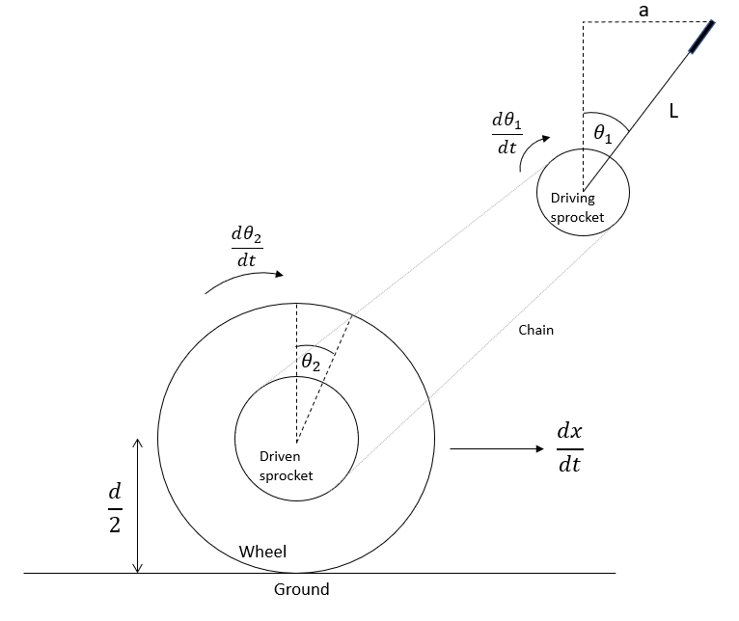

*Assumptions*

* The motion of the rider’s hand is approximated as linear (a)
* The power delivered in each stroke of the lever at top speed is sufficient to maintain constant velocity of the pulleys
* There is no slipping between the ground and the tire
* Efficiency of the sprockets and chain is 100% (conservative estimates are applied elsewhere in this calculation so using less efficiency is unnecessary)

|  |  |
| --- | --- |
| $θ_{1}=sin^{-1}(a/L)$ | (1) |
| $\frac{d θ_{1}}{dt}=\frac{d}{dt}(sin^{-1}(a/L))=(1-(a^{2}/L^{2 }))^{-1/2}*(L)^{-1}*\frac{da}{dt}$ | (1.1) |
| $\frac{d θ_{2}}{dt}=e*\frac{d θ_{1}}{dt}$ | (2) |
| $H_{rider}=F_{hand}*v_{hand} =F*\frac{da}{dt}$ | (3) |
| $\frac{dx}{dt}=\frac{{d θ}_{1}}{dt}*0.5d$ | (4) |
| $e =\frac{dx}{dt}*(0.5Hd)^{-1}*LF_{H}\sqrt{1-a^{2}/L^{2}}$ | (5) |

The governing equation for a train value based on the initial acceleration is derived based on the free body diagram shown below.

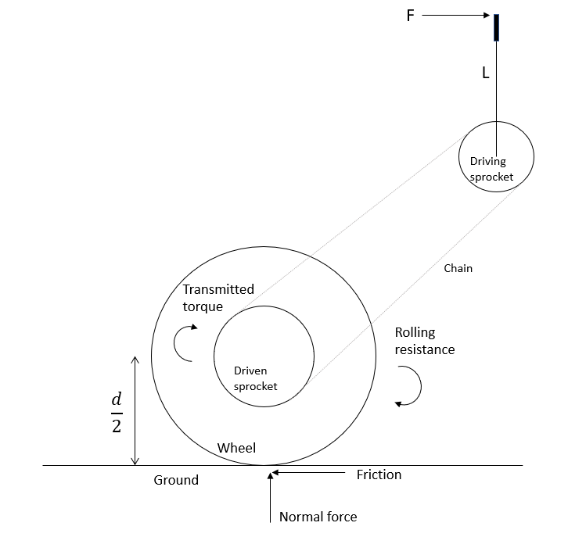

|  |  |
| --- | --- |
| $T_{in}=F_{H}L$ | (6) |
| $T_{out}=(1/e)T_{in}$ | (7) |
| $a={(2T}_{out} /d -F_{RR})/m$ | (8) |
| $Δt =(v_{f}-v_{i})/a = \frac{dx}{dt}/a$ | (9) |
| $e=2F_{H}LΔt/[d(m\frac{dx}{dt}+Δt F_{RR})]$ | (10) |

Equation 5 and Equation 10 give two relationships for the train value based on two different parameters: top speed of the device ($\frac{dx}{dt}$) and the time to reach top speed from rest ($Δt$).

#### Estimating Parameters

The next step is to estimate the values of the known parameters, which is done in the table below.

|  |  |  |  |
| --- | --- | --- | --- |
| **Parameter** | **Value** | **Units** | **Source** |
| d (wheel diameter) | 0.66 | m | 26” wheels are chosen for our device. |
| a (arm extension) | 0.4 | m | Estimate based on comfortable arm extension. |
| L (lever length) | 0.5 | m | Estimate based on other lever drive systems. |
| H (power input) | 30 | W | Requirement 7.2 states that the device should operate with no more than 40W input power. See _______** |
| FRR | 9 | N | See ____________ **insert explanation of this |
| m | 76 | kg | Estimated average mass of rider and device |

#### Calculating the train value

Equations 5 and 10 were inputted into a spreadsheet and the remaining parameters were manually iterated until a reasonable combination was achieved. The first train value calculation iteration is shown below.

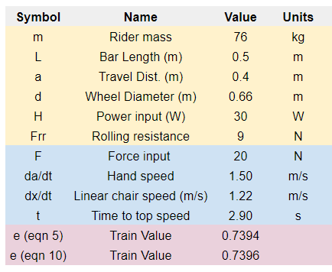

As seen, a train value of approximately 0.74 is obtained. Given that a 17 tooth pulley is chosen for the driving sprocket, this train value requires a 23 tooth driven sprocket. 24 tooth sprockets are far more common in bike cassettes, so the choice was made to use a train value of 17/24 = 0.71. The parameters in the spreadsheet were adjusted to achieve this value as shown below.

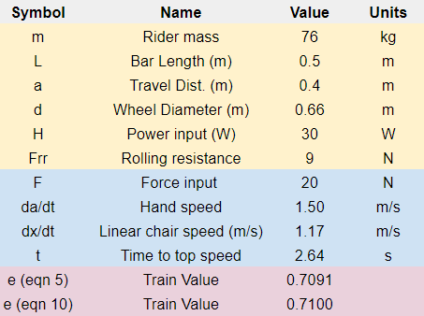

The final choice of parameters based on this process are summarized in the table below.

|  |  |  |  |
| --- | --- | --- | --- |
| **Parameter** | **Value** | **Units** | **Justification** |
| dx/dt (linear speed) | 1.17 | m/s | Estimated that average walking speed is  1 - 1.6 m/s, so this is reasonable. |
| FH (rider hand force) | 20 | N | Chosen in tandem with da/dt based on reasonable values that achieve the calculated power input. |
| da/dt (rider hand speed) | 1.5 | m/s | See the field above. |
| Δt (time to top speed) | 2.63 | s | Requirement 7.3 states that this value should be less than 5 seconds. |
| e (train value) | 0.71 | n/a | See the process above. |

Thus, 0.71 is chosen as the default train value based on an individual that can output 30W of power over the duration of the trip.

#### Variable train value option

This work does not yet address item 12.2 in the DFMEA, which states that the specified train value will not be suitable for all users due to differing physical capabilities.

The ‘action item’ for this failure mode is to use a cassette with various sprockets that allow for different train values for users upon purchase of the device. The cassette includes 28-tooth, 24-tooth and 20-tooth sprockets. The figures below show the performance of the device based on these train values, with increased power input at 40W and decreased power output at 20W.

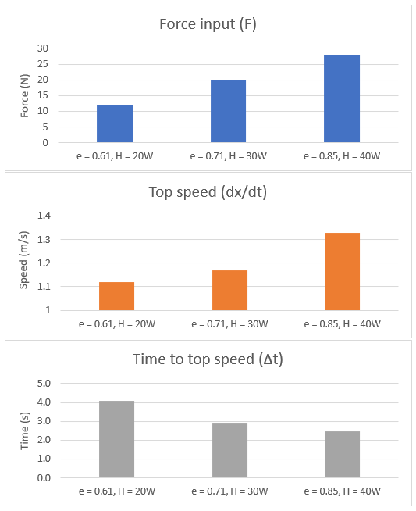

Note that the values at 20W input are near the boundaries for Requirement 7.3 and 7.4 (minimum 1 m/s top speed and maximum 5 seconds to reach top speed).

Discuss limitations as well